

Placement Empowerment Program

Cloud Computing and DevOps Centre

Back Up and Restore a Cloud Instance

Take a snapshot of your cloud VM. Terminate the VM and restore it from the snapshot.

Name:Manashaa U Department: CSE

Introduction:

In this Proof of Concept (POC), here I have created a snapshot which is used to backup the Virtual machine

Step-by-Step Overview Step

1) Go to VM

2) You will have "capture" option at the top

3) Click it

4) Fill in the necessary details

5) Your snapshot will be created

6) In the gallery your snapshot will be stored

7)Choose it

8)On top you will have an option "+create"

9)Choose create VM , fill in necessary details

10)Deploy the VM

11)Your VM is created

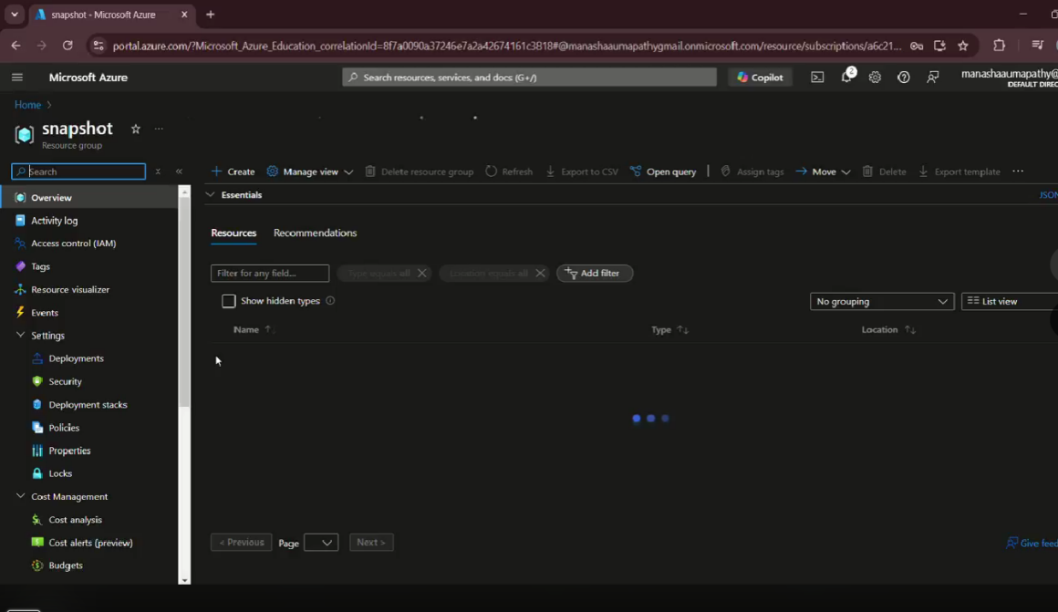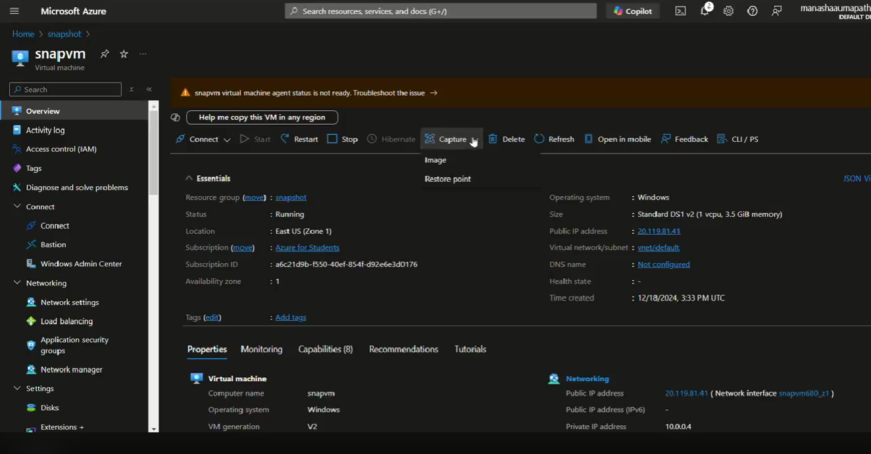

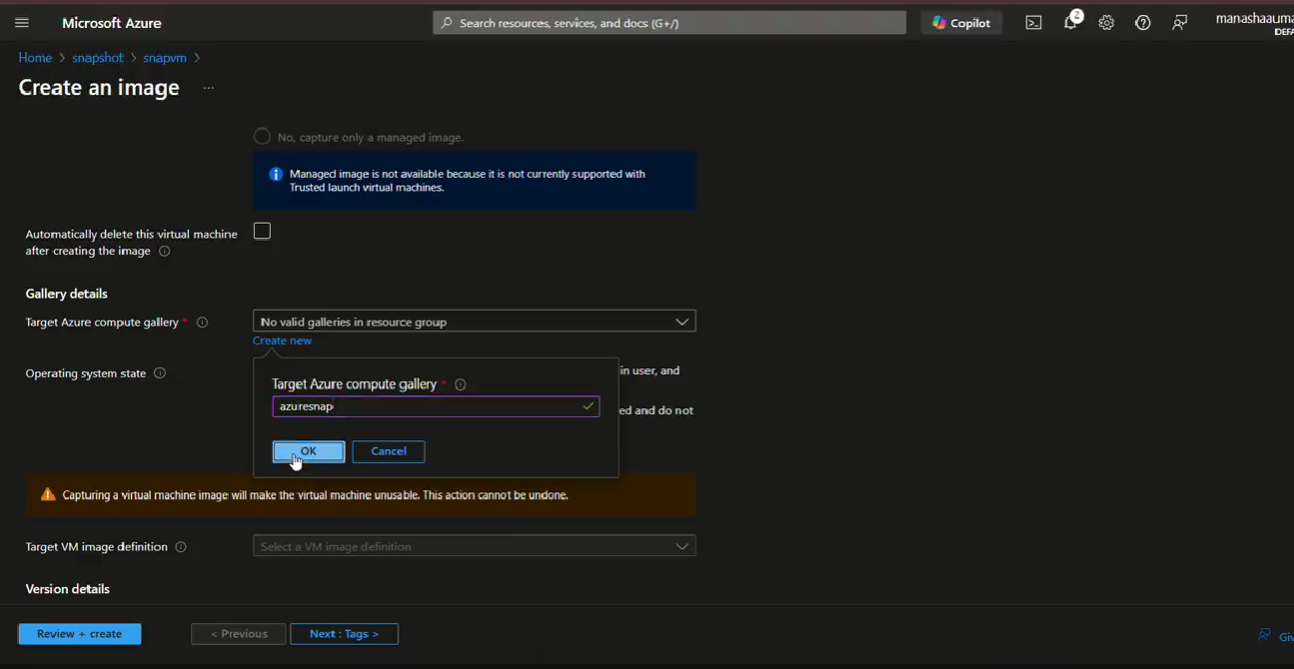

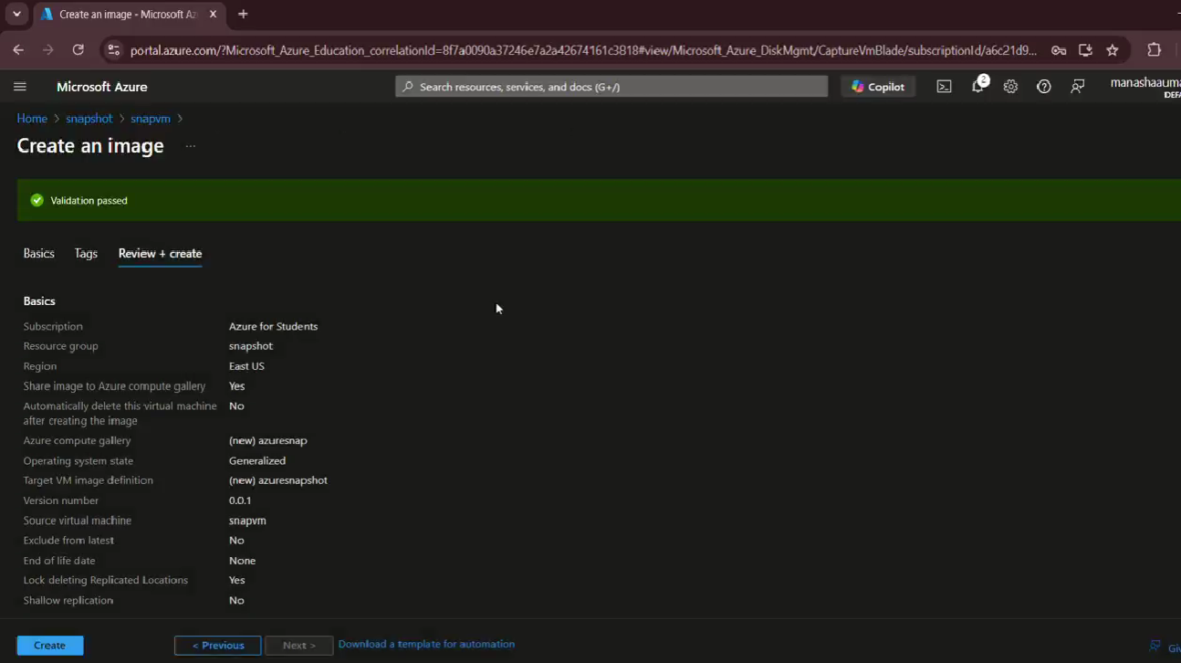

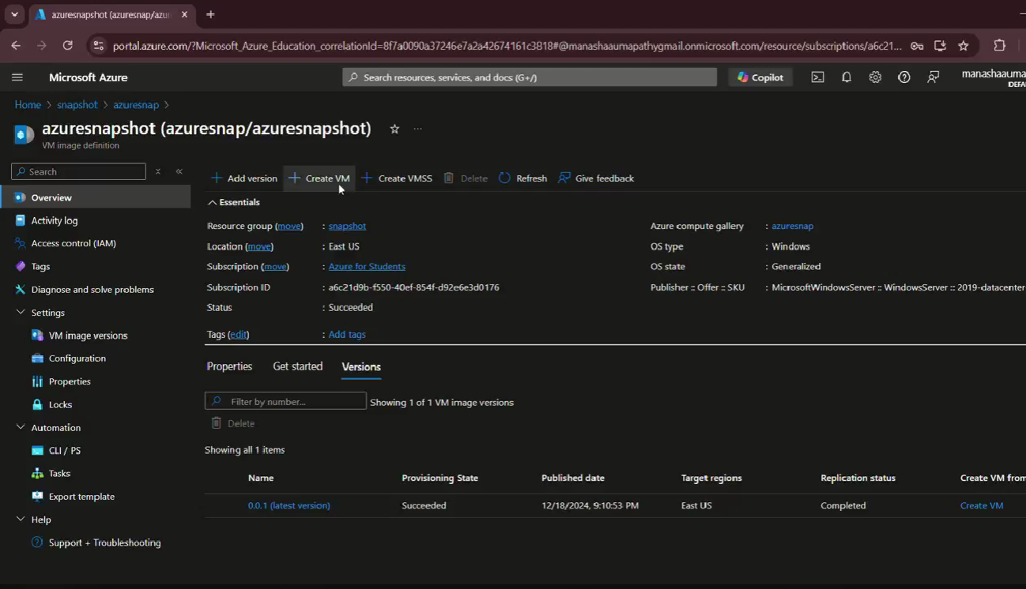

OUTCOME:

Uses of this snapshot :

It is a read only copy of VHD

Uses of snapshot:

1)used to create a new VM or restore existing one

2) used for backup